**Digital Electronics**

**Class 10**

**Lab 17**

|  |
| --- |
| Lab Objectives:  * Number System |

# Number Systems

## If base or radix of a number system is ‘r’, then the numbers present in that number system are ranging from zero to r-1. The total numbers present in that number system is ‘r’. So, we will get various number systems, by choosing the values of radix as greater than or equal to two.

## let us discuss about the popular number systems and how to represent a number in the respective number system. The following number systems are the most commonly used.

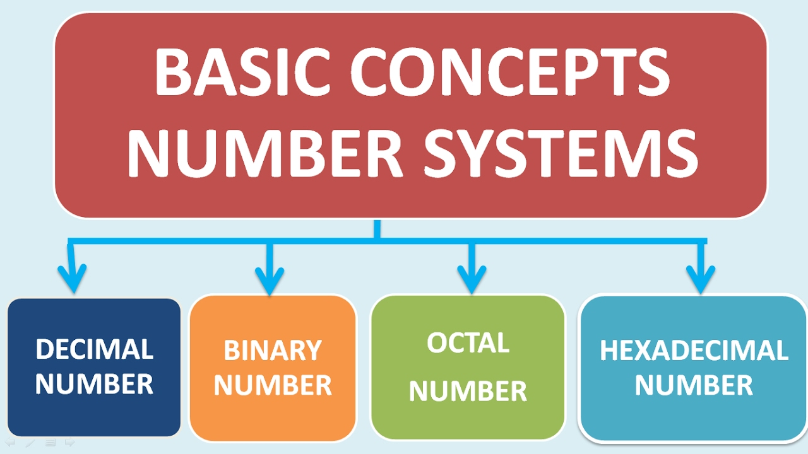

## 

# Decimal Number System

IMG_256The **base** or radix of Decimal number system is **10**. So, the numbers ranging from 0 to 9 are used in this number system. The part of the number that lies to the left of the **decimal point** is known as integer part. Similarly, the part of the number that lies to the right of the decimal point is known as fractional part.

In this number system, the successive positions to the left of the decimal point having weights of 100, 101, 102, 103 and so on. Similarly, the successive positions to the right of the decimal point having weights of 10-1, 10-2, 10-3 and so on. That means, each position has specific weight, which is **power of base 10**

# Example

Consider the **decimal number 1358.246**. Integer part of this number is 1358 and fractional part of this number is 0.246. The digits 8, 5, 3 and 1 have weights of 100, 101, 102 and 103 respectively. Similarly, the digits 2, 4 and 6 have weights of 10-1, 10-2 and 10-3 respectively.

**Mathematically**, we can write it as

1358.246 = (1 × 103) + (3 × 102) + (5 × 101) + (8 × 100) + (2 × 10-1) +

(4 × 10-2) + (6 × 10-3)

After simplifying the right hand side terms, we will get the decimal number, which is on left hand side.

# Binary Number System

All digital circuits and systems use this binary number system. The **base** or radix of this number system is **2**. So, the numbers 0 and 1 are used in this number system.



The part of the number, which lies to the left of the **binary point** is known as integer part. Similarly, the part of the number, which lies to the right of the binary point is known as fractional part.

IMG_256

In this number system, the successive positions to the left of the binary point having weights of 20, 21, 22, 23 and so on. Similarly, the successive positions to the right of the binary point having weights of 2-1, 2-2, 2-3 and so on. That means, each position has specific weight, which is **power of base 2**.

# Example

Consider the **binary number 1101.011**. Integer part of this number is 1101 and fractional part of this number is 0.011. The digits 1, 0, 1 and 1 of integer part have weights of 20, 21, 22, 23 respectively. Similarly, the digits 0, 1 and 1 of fractional part have weights of 2-1, 2-2, 2-3 respectively.

**Mathematically**, we can write it as

1101.011 = (1 × 23) + (1 × 22) + (0 × 21) + (1 × 20) + (0 × 2-1) +

(1 × 2-2) + (1 × 2-3)

After simplifying the right hand side terms, we will get a decimal number, which is an equivalent of binary number on left hand side.

# Octal Number System

The **base** or radix of octal number system is **8**. So, the numbers ranging from 0 to 7 are used in this number system. The part of the number that lies to the left of the **octal point** is known as integer part. Similarly, the part of the number that lies to the right of the octal point is known as fractional part.

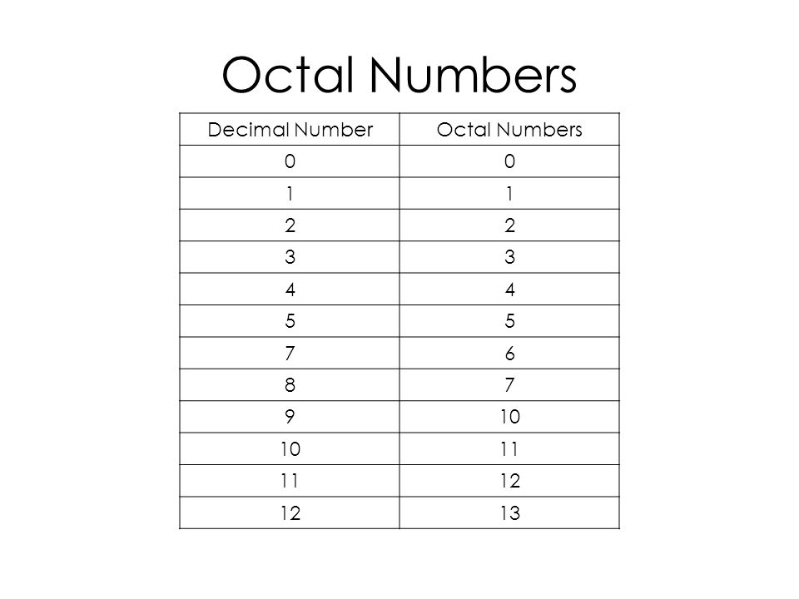

In this number system, the successive positions to the left of the octal point having weights of 80, 81, 82, 83 and so on. Similarly, the successive positions to the right of the octal point having weights of 8-1, 8-2, 8-3 and so on. That means, each position has specific weight, which is **power of base 8**.

# Example

Consider the **octal number 1457.236**. Integer part of this number is 1457 and fractional part of this number is 0.236. The digits 7, 5, 4 and 1 have weights of 80, 81, 82 and 83respectively. Similarly, the digits 2, 3 and 6 have weights of 8-1, 8-2, 8-3 respectively.

**Mathematically**, we can write it as

1457.236 = (1 × 83) + (4 × 82) + (5 × 81) + (7 × 80) + (2 × 8-1) +

(3 × 8-2) + (6 × 8-3)

After simplifying the right hand side terms, we will get a decimal number, which is an equivalent of octal number on left hand side.

# Hexadecimal Number System

The **base** or radix of Hexa-decimal number system is **16**. So, the numbers ranging from 0 to 9 and the letters from A to F are used in this number system. The decimal equivalent of Hexa-decimal digits from A to F are 10 to 15.

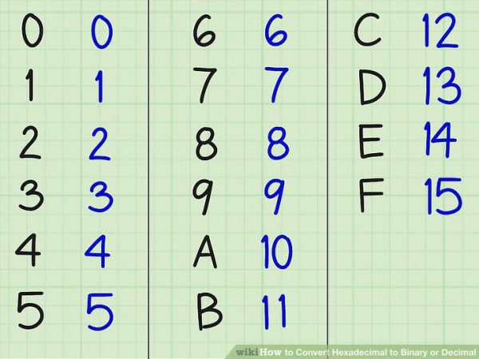

The part of the number, which lies to the left of the **hexadecimal point** is known as integer part. Similarly, the part of the number, which lies to the right of the Hexa-decimal point is known as fractional part.

In this number system, the successive positions to the left of the Hexa-decimal point having weights of 160, 161, 162, 163 and so on. Similarly, the successive positions to the right of the Hexa-decimal point having weights of 16-1, 16-2, 16-3 and so on. That means, each position has specific weight, which is **power of base 16**.

# Example

Consider the **Hexa-decimal number 1A05.2C4**. Integer part of this number is 1A05 and fractional part of this number is 0.2C4. The digits 5, 0, A and 1 have weights of 160, 161, 162 and 163 respectively. Similarly, the digits 2, C and 4 have weights of 16-1, 16-2 and 16-3 respectively.

**Mathematically**, we can write it as

1A05.2C4 = (1 × 163) + (10 × 162) + (0 × 161) + (5 × 160) + (2 × 16-1) + (12 × 16-2) + (4 × 16-3)

After simplifying the right hand side terms, we will get a decimal number, which is an equivalent of Hexa-decimal number on left hand side.

# Summery

